Checks and Questions Cyber EDR
- Check in Portal360 if the vessel has a valid Cyber EDR activation (site registered under CyberGuard EDR services with active license number)

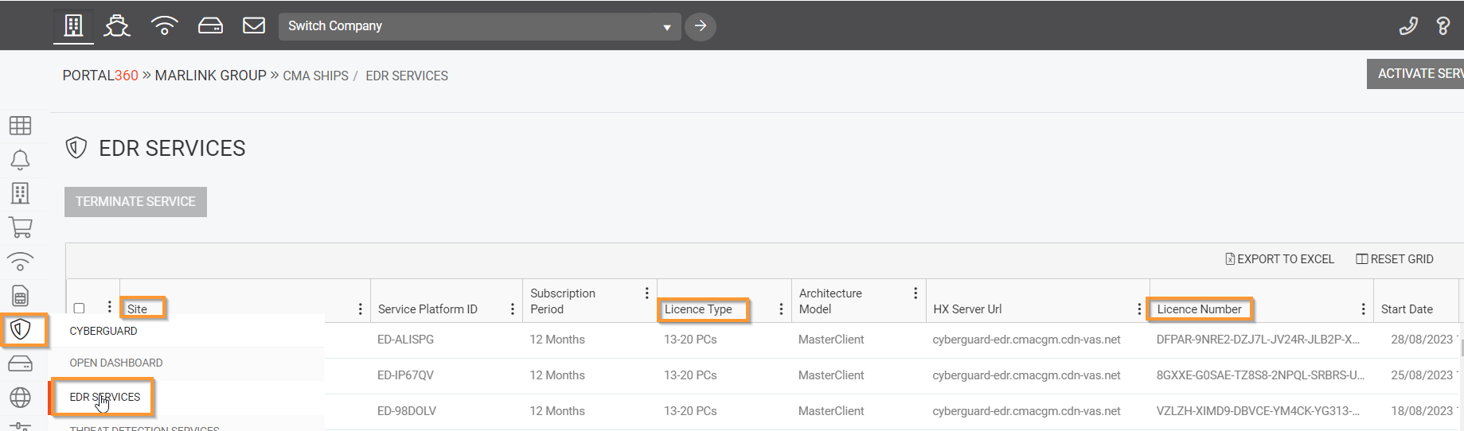

- Is the Cyber EDR Master PC connected to the internet ? If yes, what is the IP address of the PC?
- Advise the number of computers to be installed with Cyber EDR – they should be connected to the same network.
- Ensure that this number matches the number of PCs to be connected in the activation (CyberGuard EDR services – license type – number of PCs)
- Ensure that the customer has all necessary instructions (installation file, installation instructions, User Guide. In case not customer/vessel can download them here: https://marlink.com/cyberguard-edr/

